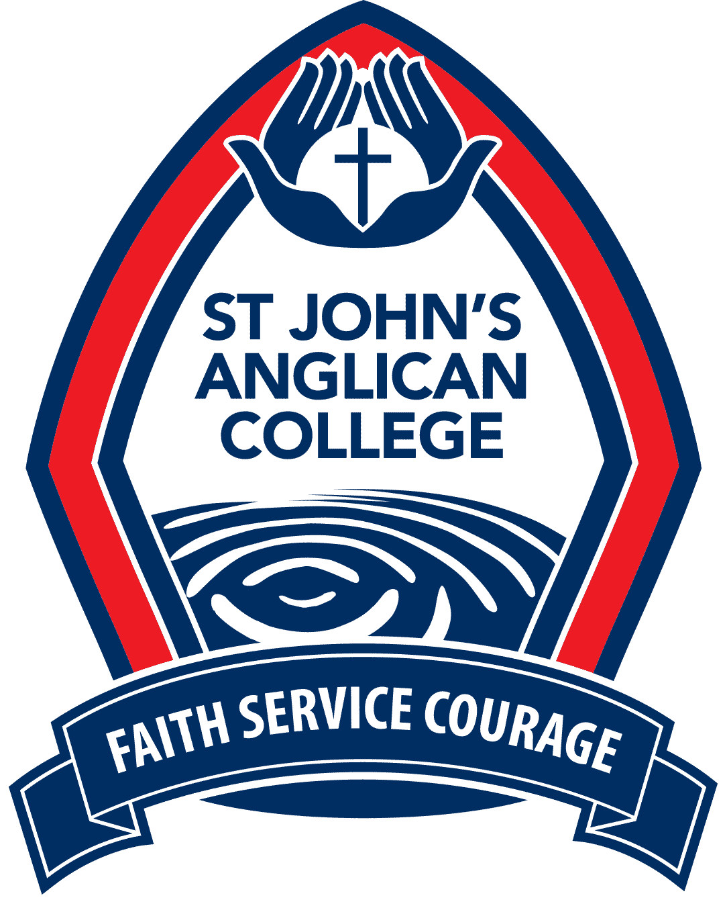

THE UNIFORM SHOP
HOLIDAY TRADING
2018/2019

Please note that we will be closed during December except by appointment.

The College Uniform Shop will be open to all existing families during the following times in January. If you are unable to make it into the Uniform Shop, orders can be placed via email or phone.

Monday 7th, Tuesday 8th, Thursday 10th Friday 11th January | 8:30am-11:30am  1:00pm-3:30pm
Monday 14th January | By appointment only
Tuesday 15th, Thursday 17th, Friday 18th January | 8:30am-11:30am  1:00pm-3:30pm
Monday 21st, Tuesday 22nd January | 8:30am-11:30am  1:00pm-3:30pm
Thursday 24th Friday 25th January | 8:30am-11:30am  1:00pm-3:30pm
Monday 28th January | Closed
Tuesday 29th January | 8:00am-11:30am  1:00pm-3:30pm
Wednesday 30th January | School Recommences  Normal Trading Hours

*The Uniform Shop will be open normal trading hours on the FIRST Wednesday back of each Term.

As back to school is always a very busy time, I encourage you not to leave your purchases till the last minute.
Thank you and I hope that you all have a safe and happy Christmas.

Mandy Willemse
Uniform Shop Manager
Ph: 07 33720181
Email: uniform@sjac.qld.edu.au

