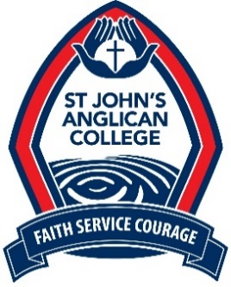
KEY SELECTION CRITERIA
Deputy Principal, Curriculum and Innovation
POSITION DETAILS
Department: | Senior Leadership Team | Location: | Secondary campus
Position reports to: | Principal
Positions reporting to this role: | Heads of Department, Subject Coordinators, Timetable Coordinator, Teaching Staff, Librarian, Careers Advisor, MYP Coordinator, Administration Officer – Curriculum and Subject Area Teacher Aides
Status: | Permanent, Full-time (accessible from 6.00am onwards during term to manage teacher relief).
Salary Level: | This is a non-Award position
Academic Qualifications required: | Master of Education, Educational Leadership
Registrations: | Queensland College of Teachers registration
Required experience: | Demonstrated success in curriculum design, development and evaluation and experience implementing educational frameworks.

KEY SELECTION CRITERIA
Please address the following questions relating to the Key Selection Criteria for this role.
Skills and Abilities: | Question 1: Using an example, demonstrate how you would identify, source and implement innovative programs and opportunities that are aligned with the strategic direction of the College.
Technical Knowledge: | Question 2: How have you been preparing for and implementing changes to the Queensland Curriculum specifically relating to the QCE?
Qualifications: | Please provide copies of your academic qualifications.
Experience: | Question 3: Please demonstrate your experience in implementing educational frameworks as the foundation for the curriculum, for example the International Baccalaureate (IB).
Personal Qualities: | Question 4: How will you ensure that St John’s continues to deliver high quality academic outcomes?

Important information
People who work for St John’s Anglican College must comply with the Code of Conduct, relevant legislation, policies and procedures.
- A Safe Ministry Check will be conducted on recommended candidates in relation to any circumstances which exist that may conflict with the candidate’s employment at St John’s Anglican College.

