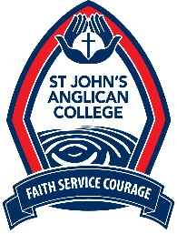
UNIFORM SHOP

Holiday Trading Times Easter 2019

Week 1 | Monday, 8 April – Friday, 12 April | CLOSED
Week 2 | Monday, 15 April – Wed, 17 April | CLOSED
 | Thursday, 18 April | 9:00 – 11:00am and 1:00 – 3:00pm
 | Easter Good Friday, 19 April & Easter Monday, 22 April | CLOSED
 | Tuesday, 23 April | First Day Term 2 – Normal Trading
 | Wednesday, 24 April | OPEN - Normal Trading Hours
 | Thursday, 25 April | CLOSED – ANZAC DAY
 | Saturday, 27 April | OPEN 7:30am – 10:00am

If you are unable to make it into the uniform shop during these times, please send your order via email uniform@sjac.qld.edu.au or phone 33720181.

Thank you and I hope you all have a safe and happy holiday break.

Mandy Willemse
Uniform Shop Manager

